P202 – See Description Below

Pin8 -------------------------Pin 1

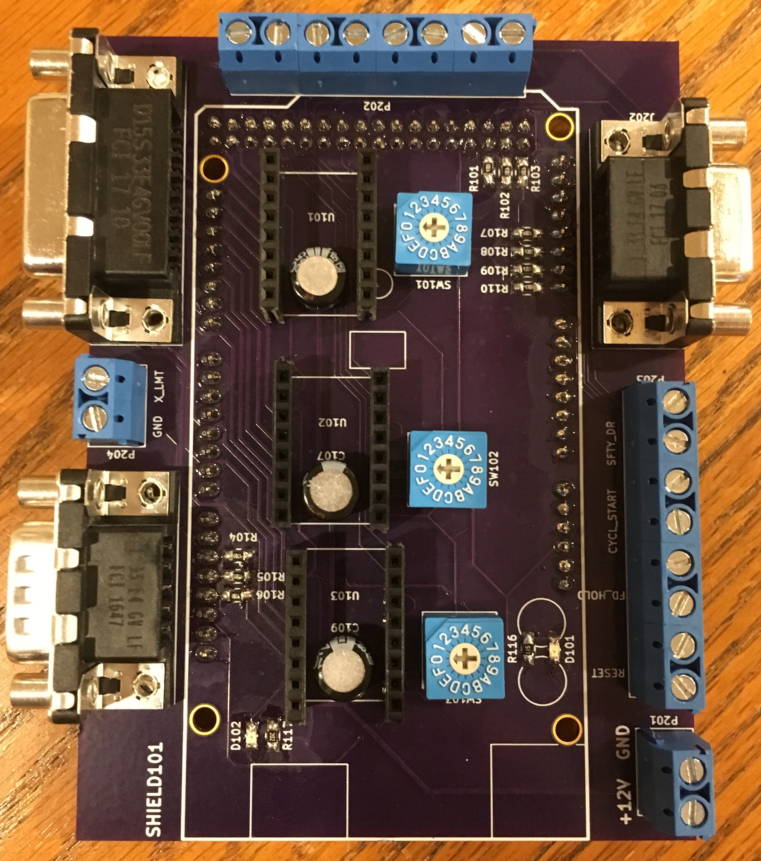

J201 – A, B, and C

Stepper Lines

J202 – A, B, and

C Limit Switches

P204 – X Limit

Switch

P203:Aux GRBL

connectors:Reset, Feed

Hold, Cycle Start, Safety Door

J203 – Y and

Z Limit Switches

P201 +12V Supply

P202 Connection Description (Right to Left):

Pin 1: ~ENABLE

Pin 2: ~Z-Dir

Pin 3: ~X-Dir

Pin 4: ~Y-Dir

Pin 5: ~Z-Step

Pin 6: ~X-Step

Pin 7: ~Y-Step

Pin 8: +5V

**CAUTION** – A4988 Stepper Controllers must be oriented so the VMOT pin is close to the electrolytic capacitor!!!!!

*Turn to the next page for More Wonderfulness . . .*

SW101, SW102, and SW103 set the micro-stepping for the A4988 stepper controllers:

0 = Full Step, 1 = Half Step, 2 = Quarter Step, 3 = Eighth Step, 7 = Sixteenth Step

Green LED indicates +5V working, Red LED indicates +12V working

Pin-outs for the J201, J202, and J203 Connectors:

